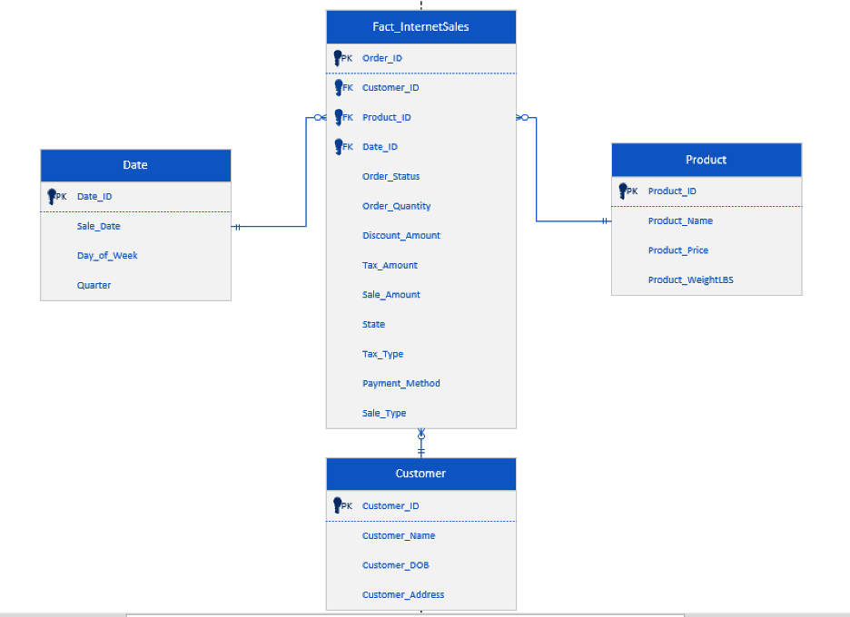

SQL SCRIPT
USE BAN621_ZF
CREATE TABLE Customer(
Customer_ID INT PRIMARY KEY,
Customer_Name VARCHAR (255),
Customer_DOB DATE,
Customer_Address VARCHAR (255)
);

CREATE TABLE Date(
Date_ID INT PRIMARY KEY,
Sale_Date DATE,
Day_of_Week VARCHAR (20),
Quarter INT
);

CREATE TABLE Product(
Product_ID INT PRIMARY KEY,
Product_Name VARCHAR (250),
Product_Price DECIMAL (10, 2),
Product_WeightLBS DECIMAL (10, 2)
);

CREATE TABLE Fact_InternetSales (
Order_ID INT PRIMARY KEY,
Order_Status VARCHAR (15),
Order_Quantity INT,
Discount_Amount DECIMAL(10,2),
Tax_Amount DECIMAL (10,2),
Sale_Amount DECIMAL(10,2),
State VARCHAR (50),
Tax_Type VARCHAR (20),
Payment_Method VARCHAR(50),
Sale_Type VARCHAR(20),
Customer_ID INT,
Product_ID INT,
Date_ID INT,
FOREIGN KEY (Customer_ID) REFERENCES Customer(Customer_ID),
FOREIGN KEY (Product_ID) REFERENCES Product(Product_ID),
FOREIGN KEY (Date_ID) REFERENCES Date(Date_ID)

);

INSERT INTO Customer (Customer_ID, Customer_Name, Customer_DOB, Customer_Address) VALUES
(91, 'Lana Del Rey', '1985-06-21', '50 Palm Street'),
(82, 'Beyonce Knowles', '1985-09-14', '40 Worth Street'),
(73, 'Shaquille O’Neal', '1962-07-14', '50 Palm Street'),
(64, 'Kevin Costner', '1960-04-11', '45 West Bay Street'),
(55, 'Stefani Germanotta', '1976-03-04', '45 Christopher Ave');

INSERT INTO Date (Date_ID, Sale_Date, Day_of_Week, Quarter) VALUES
(105, '2025-01-10', 'Friday', 1),
(106, '2025-01-11', 'Saturday', 1),
(107, '2025-01-26', 'Sunday', 1) ,
(108, '2025-02-09', 'Sunday', 2),
(109, '2025-02-14', 'Friday', 2);

INSERT INTO Product ( Product_ID, Product_Name, Product_Price, Product_WeightLBS) VALUES
(245, 'Int_Package 1', 500.00, 1.00),
(246, 'Int_Package 2', 1000.00, 2.50),
(247, 'Int_Package 1', 500.00, 1.00),
(248, 'Int_Package 4', 2000.00, 4.00),
(249, 'Int_Package 3', 1500.00, 3.00);

INSERT INTO Fact_InternetSales (Order_ID, Order_Status, Order_Quantity, Discount_Amount, Tax_Amount, Sale_Amount, State, Tax_Type, Payment_Method, Sale_Type, Customer_ID, Product_ID, Date_ID) VALUES
(1, 'Delivered', 10, 750.00, 8.50, 4258.50, 'New York', 'State Tax', 'Credit Card', 'Internet', 91, 245, 105),
(2, 'Delivered', 1, NULL, 6.25, 1006.25, 'Texas', 'State Tax', 'ACH', 'Internet', 82, 246, 106),
(3, 'Canceled', 12, 1200.00, 5.75, 4805.75, 'Florida', 'State Tax', 'Credit Card', 'Internet', 73, 247, 107),
(4, 'Shipped', 2, NULL, 7.25, 4007.25, 'California', 'State Tax', 'Credit Card', 'Internet', 64, 248, 108),
(5, 'Pending', 4, 600.00, 8.50, 5908.50, 'New York', 'State Tax', 'ACH', 'Internet', 55, 249, 109);

Query
USE BAN621_ZF;

SELECT
C.Customer_Name,
D.Sale_Date,
P.Product_Name,
FI.Order_Quantity,
FI.Discount_Amount,
FI.Sale_Amount,
FI.Tax_Amount
FROM Fact_InternetSales FI
JOIN Customer C ON FI.Customer_ID = C.Customer_ID
JOIN Date D ON FI.Date_ID = D.Date_ID
JOIN Product P ON FI.Product_ID = P.Product_ID
ORDER BY D.Sale_Date;

SCREENSHOTS

Table Creation

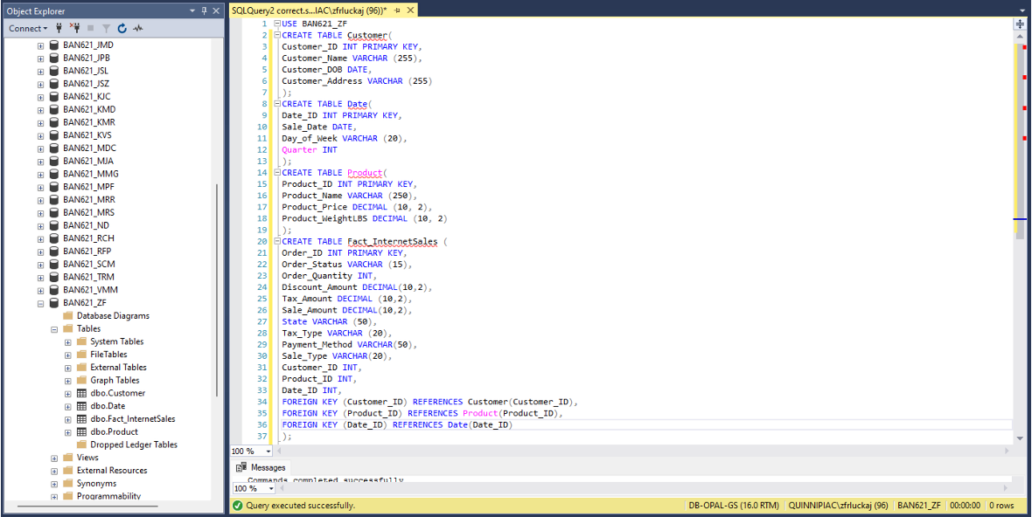

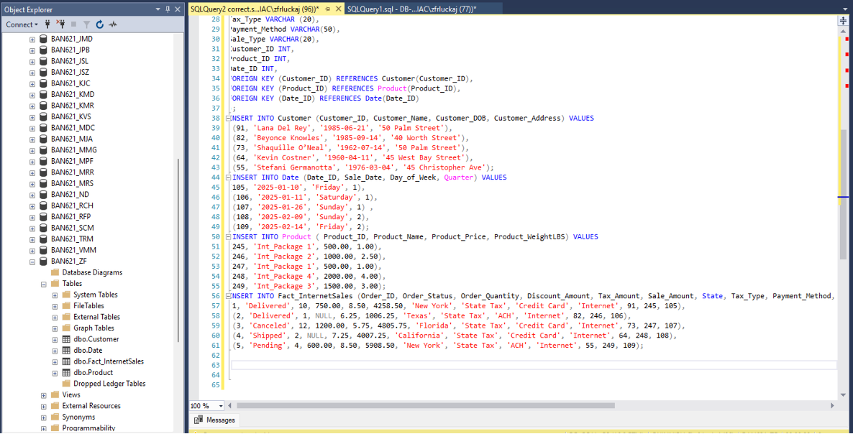

Inserted Data

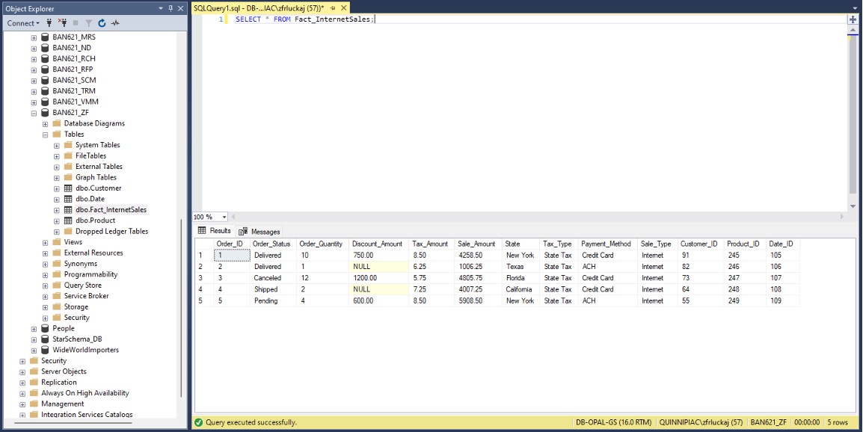
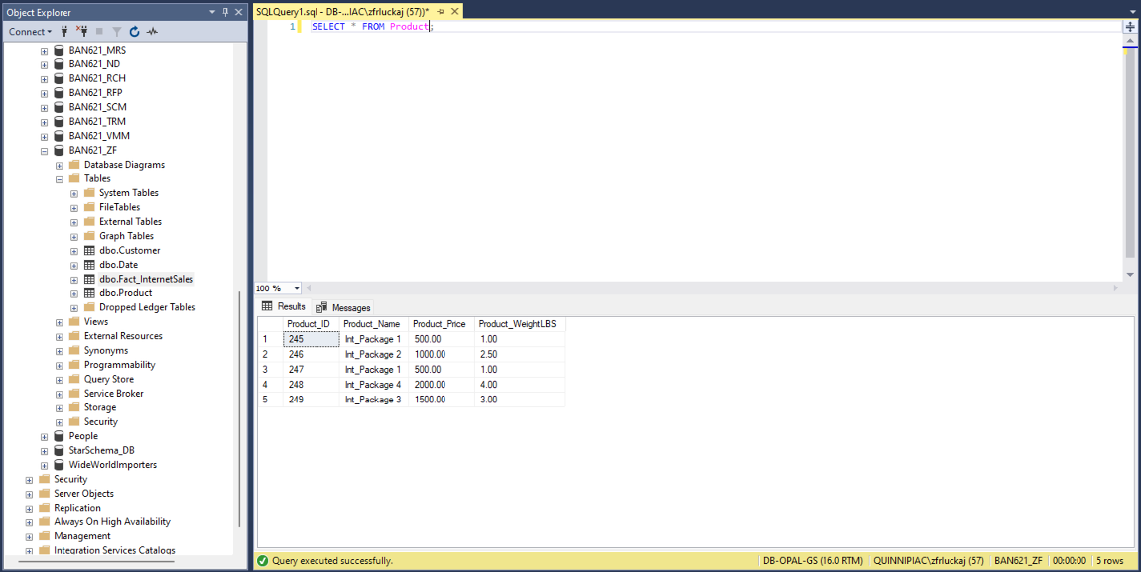

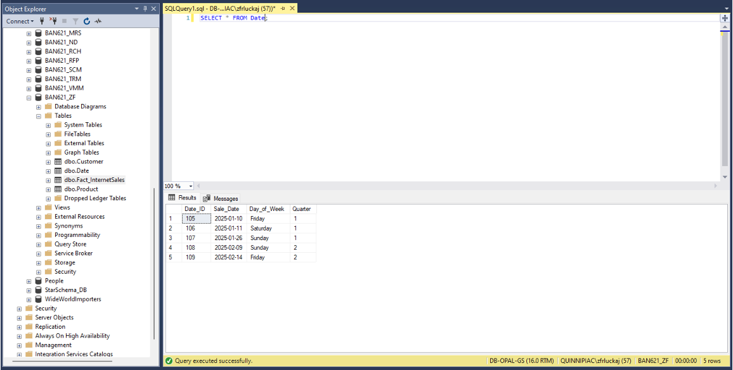

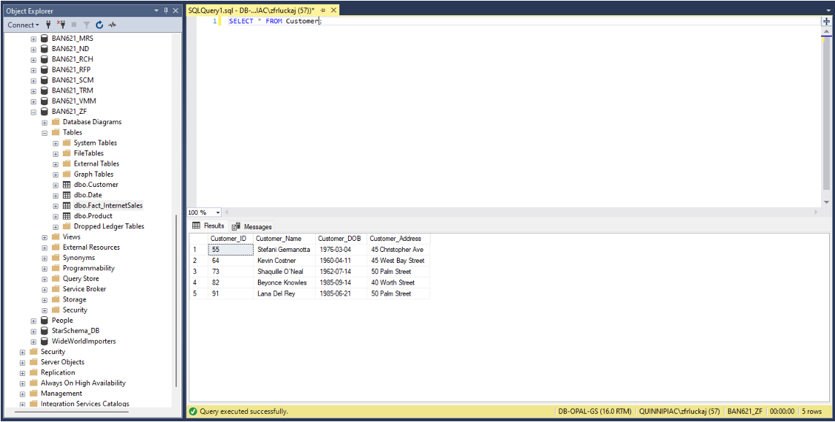

Query Results
